2024 Model Warranty
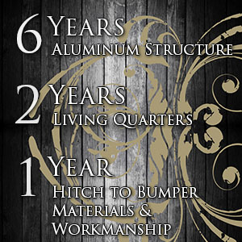
Lakota's warranty is among the best in the business with a 6 year warranty on the aluminum structure, a 2 year warranty on the living quarters, and 1 year hitch to bumper workmanship and materials.
Lakota personally builds your trailer AND your trailer's conversion. This is extremely convenient for owners because there is no finger pointing between the manufacture and conversion company if an issue arises with your unit.
Once you buy Lakota we are family and work hard to treat you that way!

